SOURCE ANALYSIS – Intro to Source Analysis Practice GROUP MEMBERS:__________________________________________________________________________________

THINK ABOUT: Source analysis questions. What do you think it teaches us about the civilisation? What assumptions can you make about them, based on this source?

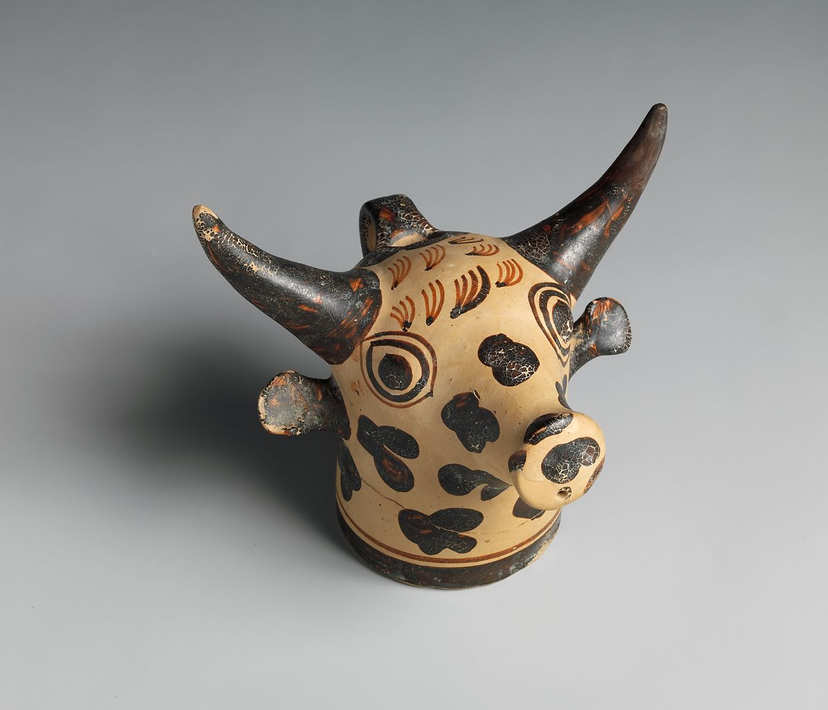

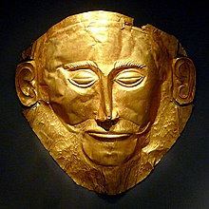

MYCENAEAN: Death Mask known as the ‘Mask of Agamemnon’

c. 1500 BCE

MINOAN: Terracotta vase in the form of a bull's head c. 1450–1400 BCE

SOURCE ANALYSIS – Intro to Source Analysis Practice GROUP MEMBERS:__________________________________________________________________________________

THINK ABOUT: Source analysis questions. What do you think it teaches us about the civilisation? What assumptions can you make about them, based on this source?

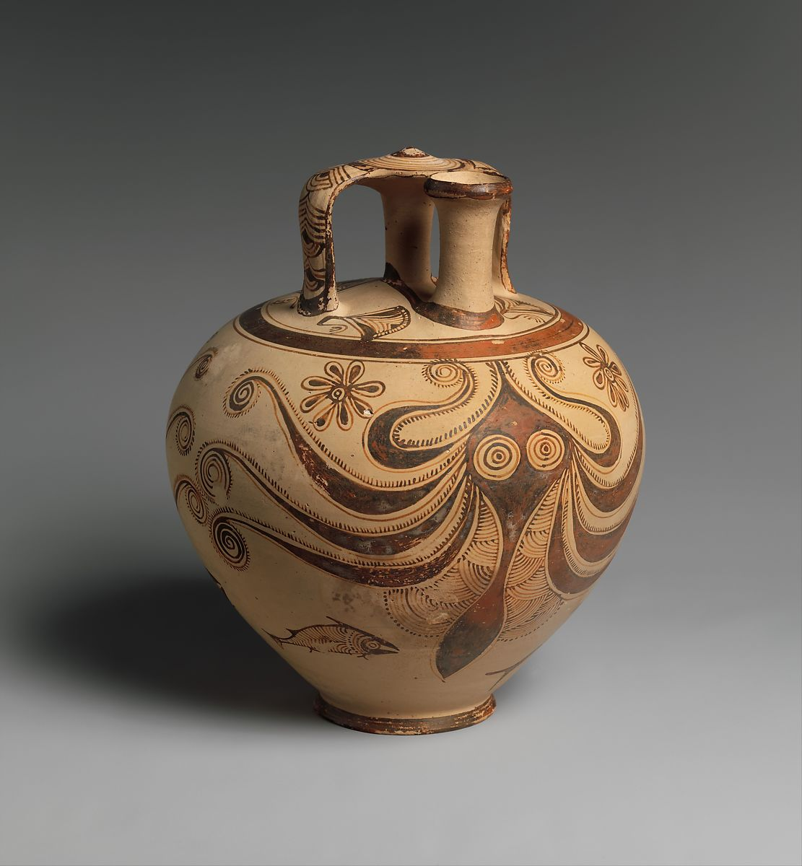

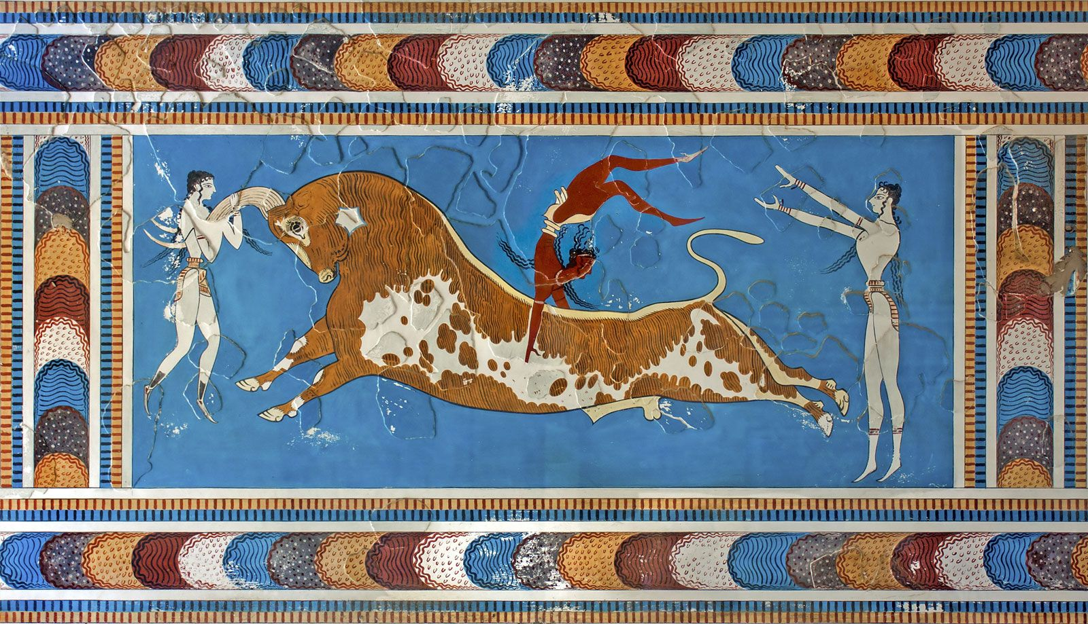

MINOAN: Toreador Fresco

c. 1550 BCE

MYCENAEAN: Terracotta Stirrup Jar with octopus

c. 1200 – 1100 BCE